|  |  |
| --- | --- |
| [KAN-3] [The system allows subscriptions using an address longer than 254 characters](https://tmelnychok30.atlassian.net/browse/KAN-3) Created: 14/вер./24  Updated: 17/вер./24 | |
| **Status:** | To Do |
| **Project:** | [Pet-Project AI Guru](https://tmelnychok30.atlassian.net/secure/BrowseProject.jspa?id=10000) |
| **Components:** | None |
| **Affects versions:** | None |
| **Fix versions:** | None |

|  |  |  |  |
| --- | --- | --- | --- |
| **Type:** | Bug | **Priority:** | Medium |
| **Reporter:** | [Tetiana Melnychok](https://tmelnychok30.atlassian.net/secure/ViewProfile.jspa?accountId=712020%3A4e68e605-a434-4948-bfa8-bb53c39de0a3) | **Assignee:** | [Tetiana Melnychok](https://tmelnychok30.atlassian.net/secure/ViewProfile.jspa?accountId=712020%3A4e68e605-a434-4948-bfa8-bb53c39de0a3) |
| **Resolution:** | Unresolved | **Votes:** | 0 |
| **Labels:** | functional | | |
| **Remaining Estimate:** | Not Specified | | |
| **Time Spent:** | Not Specified | | |
| **Original estimate:** | Not Specified | | |

|  |  |
| --- | --- |
| **Attachments:** | Screenshot_2.png |
| **Issue links:** | |  |  |  |  | | --- | --- | --- | --- | | **Blocks** | | | | | blocks | [~~KAN-7~~](https://tmelnychok30.atlassian.net/browse/KAN-7) | Testing of the newsletter | Done | |
| **Rank:** | 0|i00007: |

|  |  |
| --- | --- |
| **Description** |  |

|  |
| --- |
| **Steps:** 1. Follow the link: <https://aiguru.com.ua/> 2. Scroll down the home page of a website to the mailing list field 3. Enter an email with a total length of more than 254 characters in the email input field; for example: "aaaaaaaaaaaaaaaaaaaaaaaaaaaaaaaaaaaaaaaaaaaaaaaaaaaaaaaaaaaaaaaaaaaaaaaaaaaaaaaaaaaaaaaaaaaaa  Aaaaaaaaaaaaaaaaaaaaaaaaaaaaaaaaaaaaaaaaaaaaaaaaaaaaaaaaaaaaaaaaaaaaaaaaaaaaaaaaaaaaaaaaaaaaaa  aaaaaaaaaaaaaaaaaaaaaaaaaaaaaaaaaaaaaaaaaaaaaaaaaaaaaaaaaaaaaaaaaaaaaaaaaaaaaa@example.com" 4. Click on the "Підписатися" button  **Expected result:**  The button is clickable; the message "Не коректна електронна адреса" appears  **Actual result:** Subscription to the newsletter is completed, the system skips this email, the message "Дякуємо за підписку. Тепер ви будете в курсі усіх важливих подій на AI Guru" appears |

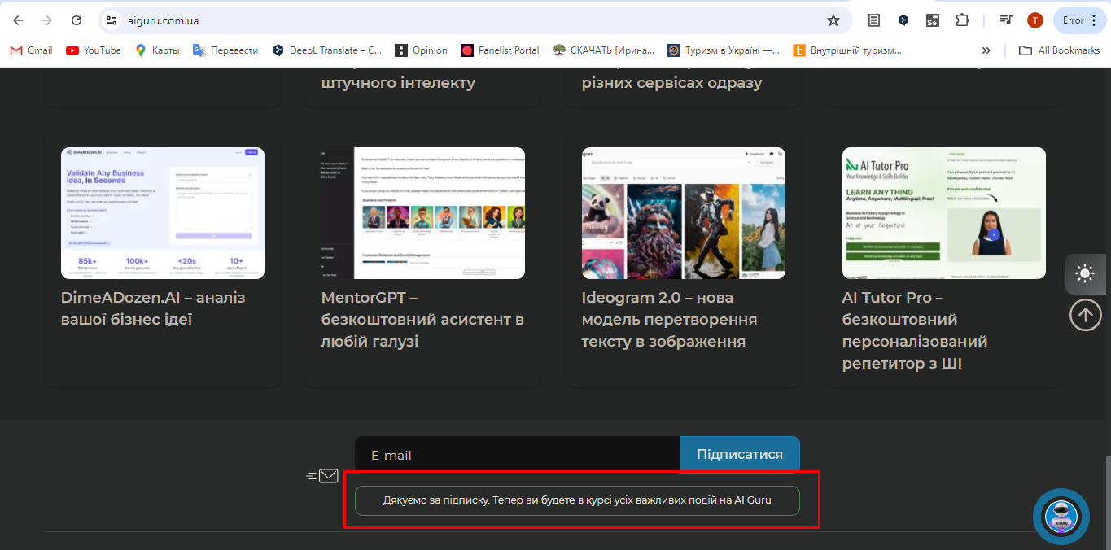

Generated at Tue Sep 17 17:09:23 UTC 2024 by Tetiana Melnychok using Jira 1001.0.0-SNAPSHOT#100266-rev:bccdae9a1b3c45b4ace2d33db0008d855c13cad7.